*A Socially Relevant* *Project Report*

*on*

**SMART ALERT SYSTEM FOR EARLIER FIRE AND SMOKE DETECTION IN BUILDINGS USING SENSORS AND ARDUINO UNO**

*Submitted in partial fulfilment of the requirement for the award of*

**BACHELOR OF TECHNOLOGY**

*in*

**CIVIL ENGINEERING**

*Submitted by*

**REDDI NAIK. M 20125A0108**

**DEVENDRA. N 20125A0109**

**AZARUDDIN. P 20125A0111**

**KRISHNA SAI. V 20125A0113**

**REDDAIAH. K 20125A0122**

*Under the Guidance of*

***Supervisor***

**Mr. M. P. CHARAN SAI, M. Tech.**

*Assistant Professor, Dept. of Civil Engineering*



Department of Civil Engineering

**(Affiliated to JNTUA, Ananthapur, approved by AICTE, New Delhi, Accredited by NBA and NAAC 'A')**

**SreeSainath Nagar, A. Rangampet, Tirupati, Andhra Pradesh – 517102**

**2021**

*A Socially Relevant* *Project Report*

*on*

**SMART ALERT SYSTEM FOR EARLIER FIRE AND SMOKE DETECTION IN BUILDINGS USING SENSORS AND ARDUINO UNO**

*Submitted in partial fulfilment of the requirement for the award of*

**BACHELOR OF TECHNOLOGY**

*in*

**CIVIL ENGINEERING**

*Submitted by*

**REDDI NAIK. M 20125A0108**

**DEVENDRA. N 20125A0109**

**AZARUDDIN. P 20125A0111**

**KRISHNA SAI. V 20125A0113**

**REDDAIAH. K 20125A0122**

*Under the Guidance of*

***Supervisor***

**Mr. M. P. CHARAN SAI, M. Tech.**

*Assistant Professor, Dept. of Civil Engineering*



Department of Civil Engineering

**(Affiliated to JNTUA, Ananthapur, approved by AICTE, New Delhi, Accredited by NBA and NAAC 'A')**

**SreeSainath Nagar, A. Rangampet, Tirupati, Andhra Pradesh – 517102**

**2021**

**SREE VIDYANIKETHAN ENGINEERING COLLEGE**

(AUTONOMOUS)

**(Affiliated To JNTUA, Ananthapuramu, Approved by AICTE, New Delhi, Accredited by NBA AND NAAC 'A')**

**Sree Sainath Nagar, A. Rangampet, Tirupati–517502**

DEPARTMENT OF CIVIL ENGINEERING



Certificate

*This is to certify that the socially relevant project report entitled*

**SMART ALERT SYSTEM FOR EARLIER FIRE AND SMOKE DETECTION IN BUILDINGS USING SENSORS AND ARDUINO UNO**

*is the bonafide work done and submitted by*

**REDDI NAIK. M 20125A0108**

**DEVENDRA. N 20125A0109**

**AZARUDDIN. P 20125A0111**

**KRISHNA SAI. V 20125A0113**

**REDDAIAH. K 20125A0122**

in the Department of Civil Engineering, Sree Vidyanikethan Engineering College, A. Rangampet,inpartial fulfilment of the requirements for the award of the degree of **Bachelor of Technology in Civil Engineering** during the academic year 2021-2022.

|  |  |
| --- | --- |
| ***Supervisor*** | ***Head of the Department*** |
| **Mr. M. P. Charan Sai**  **Assistant Professor** | **Dr.Hemadri Prasad Raju**  **Associate Professor and Head** |

Submitted for III B.Tech. I Semester socially relevant project held on .........................................at Sree Vidyanikethan Engineering College, A.Rangampet, Tirupati.

***Examiner - 1 Examiner - 2***

***(Supervisor) (Senior Faculty)***

**ACKNOWLEDGEMENT**

Successful completion of any project work cannot be done without proper guidance and encouragement of many people, this acknowledgement transcends the reality. Hence, we express our deep sense of gratitude to all those who have directly or indirectly helped us in completion of this *socially relevant* project.

We deeply indebted to our supervisor **Mr. M. P. CHARAN SAI,** Assistant Professor, Department of Civil Engineering for his valuable guidance, constant encouragement and constructive criticism throughout the course of project work. We are really fortunate to associate ourselves with such an advising and helping supervisor in every possible way, at all stages.

We would like to express our sincere thanks to **Dr. HEMADRI PRASAD RAJU**, Associate Professor and Head, Department of Civil Engineering for his encouragement and support during the project work.

We profusely thank **Dr. B. M. SATISH,** Principal, SVEC for his continuous support and encouragement. We are pleased to express our heartfelt thanks to our Faculty of Civil Engineering for their moral support and good wishes.

Finally, we would thank our parents and our team members for their support without which this would not have been completed.

**REDDI NAIK. M 20125A0108**

**DEVENDRA. N 20125A0109**

**AZARUDDIN. P 20125A0111**

**KRISHNA SAI. V 20125A0113**

**REDDAIAH. K 20125A0122**

**ABSTRACT**

In recent years, fire accidents have become pretty common across the globe either it is a residential area, industrial building, or public domain consequently thousands of people are losing lives and millions of properties are getting wasted. Besides, it is also becoming an environmental thread creating tones of pollution. Nevertheless, identification of this fire opening in the early stages can be a possible solution to the problem by which it can be arrested to minimize the ill effects of the fire. In connection to that, this project aims to devise an instrument that can detect fire as well as smoke and alert the surrounding people or concerned authorities in nearby locations. To achieve that a technology based on IoT is employed such as heat, fire, and smoke detecting sensors are aided in this project coupled with Arduino Uno circuit boards which are highly reliable as well as durable to implement in society. In addition to that, an SMS alert will be generated and sent to all the nearby people using GSM technology which helps people to evacuate from the location. To conclude, implementation of this device either in residential or public structures or in farming areas, or a forest area can be a feasible solution to identify fire opening as soon as possible.

**Keywords:** Fire accidents, Sensors, Arduino Uno, IoT, GPS

**CONTENTS**

**Certificate i Acknowledgement ii**

**Abstract iii**

**Contents iv**

**List of Figures**

**1. INTRODUCTION 1**  1.1 GENERAL 1

1.2. FIRE ALARM SYSTEM 2

1.3. BACKGROUND OF THE PROJECT 2

* 1. SCOPE OF THE PROJECT 3
  2. PURPOSE OF THE PROJECT 3
  3. SIGNIFICANCE OF THE PROJECT 3

**2.** **LITERATURE REVIEW** **4**

1. GENERAL 4
2. LITERATURE REVIEW 4
3. RECENT FIRE ACCEDENT IN DELHI 6
4. RECENT FIRE ACCEDENT IN CHINA 6
5. SUMMARY 7

**3.** **METHODOLOGY**  **8**

1. COMPONENTS REQUIRED 8
2. WORKING PRINCIPLE OF THE FIRE AND 15

SMOKE DETECTING SYSTEM

3.3. C PROGRAMMING CODE FOR FIRE AND 17

SMOKE DETECTING SYSTEM

3.4. ADVANTAGES OF THE FIRE AND SMOKE 26

DETECTING SYSTEM

3.5. LIMITATIONS OF THE FIRE AND SMOKE 26

DETECTING SYSTEM

3.6. CONCLUSION 27

**REFERENCES 28**

**LIST OF FIGURES**

|  |  |  |
| --- | --- | --- |
| **Fig. No.** | **Description** | **Page No.** |
| 1  2  3  4  5  6  7  8  9  10  11 | Arduino uno  GSM Module  Flame sensor  Smoke detector  Buzzer  Breadboard  LCD display  GPS sensor  Plan for fire and smoke detection system  Fire and smoke detection system model  Flow chart of the fire and smoke detection system | 8  9  10  11  12  13  14  15  16  16  17 |
|  |  |  |
|  |  |  |
|  |  |  |
|  |  |  |
|  |  |  |
|  |  |  |
|  |  |  |
|  |  |  |
|  |  |  |

**1. INTRODUCTION**

**1.1 GENGERAL**

Fire hazards can be very dangerous and cause human loss. The only solution to mitigate these losses is responding to such emergency quickly. In developed countries like the USA, Singapore, etc it is government rule to install a fire alarm in all homes towards alerting home owners and Fire service personnel in time for action. Such kind of Fire Alarm system doesn’t exist in developing countries like India which result in a lot of losses and damage. In such situations, detecting the fire well in advance and alerting would reduce losses of property and life. A fire or smoke alarm system can be monitored locally or remotely as appropriate.

A Remote alarm system provides the benefit of monitoring the premise from a distant location and taking immediate action based on a message received, unlike a manual system. These Remote monitoring systems can be developed in various ways using technologies like wireless sensor networks, Ethernet, image processing, and other digital communication technologies. Though these systems are reliable and have a lot of advantages, there are still lots of concerns about being complex, incompact, expensive, and having unnecessary accessories. So there is a need for developing a system that is good and flexible as well as simple, easily implementable, and cost-effective from point of view of households in developing countries.

Fire hazards cause sad incidents throughout the world, especially in developing countries where the fire-safety measures are precarious and often inadequate. Although several systems are used in practical layouts, a reliable, easily implementable, and the cost-effective automated fire-alarm system is not available. The existing fire alarm system in the market nowadays is too complex in terms of its design and structure. Since the system is too complex, it needs regular preventive maintenance to be carried out to make sure that th system operates well. Meanwhile, when the maintenance is being done to the existing system, it could raise the cost of using the system. Therefore, the developed FAS are designed with a low-cost microcontroller and all level users can have one for safety purposes. So there the fire, raise an alarm and also at times initiate fire extinguishing too. The systems are equipped with an LM35 Flame sensor that can detect unfavorable accidental situations, as it happens, and with the help of a processing unit can alert instantly via GSM and buzzer for undertaking cautious measures at the premises. The entire system has been developed using Arduino Uno Microcontroller, LM35 Flame Sensor, and GSM SIM 900.

**1.2 FIRE ALARM SYSTEM**

Fire Alarm System is designed to alert us to an emergency so that we can take action to protect ourselves, staff and the general public. Fire alarms are found in Offices, Factories, and public buildings, they are a part of our everyday routine but are often overlooked until there is an emergency at which point, they might just save our lives. Whatever the method of detection is, if the alarm is triggered, sounders will operate to warn people in the building that there may be a fire and to evacuate. The fire alarm system may also incorporate a remote signal system which could then alert the fire brigade via a central station. So what is a fire alarm system, or fire detection system? In this article, we will have a look at the structure and types of the “Fire Alarm Systems”. The “Brain” of the fire detector system is the Fire Alarm Control Panel. It is the central hub for all of the detector signals to be wired to and provides a status indication to the users. The unit can also be set up to simulate an alarm for use in routine Fire and evacuation drills, so all staff knows what action to take in the event of a real fire.

**1.3 BACKGROUND OF THE PROJECT**

The very first fire alarm system was invented by Dr . William F. Channing and Moses Farmer in 1852, and their original design was two fire alarm boxes, each containing a telegraphic key with a handle attached. When someone detected a fire, they would crank the handle, which would then relay the details of the fire alarm box number to a central alarm station. The operator at the station would receive the message, which would then be forwarded to the fire department.

Francis Robbins Upton was the man responsible for designing the first electric fire alarm, but when he patented the design in 1890, the patenting office mistakenly recorded it as the “Portable Electric Tire Alarm”. Although the design was largely unpopular at first and received little attention, it soon became apparent that the need for this device was growing. It wasn’t until the 21st century that modern day systems were introduced and with the introduction of the British Standards Specifications Alarm Systems are more and more vital to business and everyday life.

**1.4 SCOPE OF THE PROJECT**

In this project, we will go over how to build a smoke sensor circuit using LDR. This reports smoke by the voltage level that it outputs. The more smoke there is, the greater the voltage that it outputs. Conversely, the less smoke that it is exposed to, the less voltage it outputs.

The circuit a potentiometer is used to adjust the sensitivity to smoke. By adjusting the potentiometer, you can change how sensitive it is to smoke, so it's a form of calibrating it to adjust how much voltage it will put out in relation to the smoke it is exposed to.The Output pin gives out the voltage reading, which is proportional to the amount of smoke that the sensor is exposed to. Again, a high voltage output means the sensor is exposed to a lot of smoke. A low or 0 voltage output means the sensor is exposed to either little or no smoke.

**1.5 PURPOSE OF THE PROJECT**

Fire is one of the most costly causes of damage and loss of life in a facility. Fire alarm system supervises the facility for smoke and heat in the installed environment. The purpose of this work is to design a device that does such function The primary advantage of a home fire alarm system is increased reliability and the ability to place alarms and bells exactly where needed. However, the reason most people have them is that they wanted a burglar alarm system and the cost of adding fire alarm features to a residential burglary system is relatively small.

**1.6** **SIGNIFICANCE OF THE PROJECT**

The primary advantage of a home fire alarm system is increased reliability and the ability to place alarms and bells exactly where needed. However, the reason most people have them is that they wanted a burglar alarm system and the cost of adding fire alarm features to a residential burglary system is relatively small.

Another advantage is that they are the only way to obtain remote monitoring services. This becomes important in cases where family members may not be capable of escaping from a fire without assistance. For example, if you have an older or physically impaired person in your home and a fire started when no one was home to assist that person, alarms alone might not be enough to assure their safety. A feature of most monitoring services is the ability to keep special information on the residence which comes up on the computer screen whenever an alarm is received from that home. Thus, if there is a disabled person in the home who needs special assistance this fact will be known to the operator and can be passed along to the fire department.

**2. LITERATURE REVIEW**

**2.1 GENERAL**

In the previous chapter the definition and history of fire and smoke detecting system were discussed. In this

Present chapter the reviews of different literatures are discussed.

**2.2 LITERATURE REVIEW**

**Suresh. S., Yuthika. S., Adithya Vardhini. G., et.al., (2016)** Fire warning system is important system towards securing homes and organization. Lot of research work and system developed towards Fire warning system which includes vision, image processing and so. But all these systems are not economical and affordable by every home owner in developing countries. So accordingly we here have developed an Arduino based Fire monitoring and alarm system for home owner’s primarily as to protect homes from any property loss , human loss from fire incident. This system driven by Arduino is economical and cheaper which can be deployed in all homes. The system implemented in Arduino allows the LM35 sensor to sense the temperature and send alert message via GSM to home owner which are shown as screenshots. Also the performance of the system been tested too. The designed systems have coverage up to 100 square meter area. The system can be further developed with added features with intelligence towards analyzing the intensity of fire and accordingly communicating not only to home owner’s but also nearest fire service personal for attention. In addition the system should be interface with web server interconnect, fire area tracking and fire extinguisher interfacing etc. Lastly the Government should impose rule that automatic fire extinguisher system must be installed in all homes to protect invaluable lives and assets from fire and assure safety.

**Iftekharul Mobin. Md., Abid-Ar-Rafi. Md., Neamul Islam. Md., Rifat Hasan. Md., et.al., (2016)** There is an immense need of implementation of automatic fire extinguishing system to protect lives and assets from fire hazards. In this paper full fire protection system is explained. SFF takes most of the preliminary initiative to prevent fire from spreading and does all necessary activities. Hence it’s a complete package of fire protection system. This type of system is absolutely necessary for the perspective of Bangladesh. Garments factories industries, multi complex shopping malls, super shops, this type of system is not only a requirement must be mandatory. Government should impose rule that SFF or automatic fire extinguisher system must be installed. Hence, this noble system can be used in every smart buildings and cities to protect invaluable lives and assets from fire and assure safety.

**Mahzan. M N., Enzai. N I M., Zin. N M., et.al.,(2018)** The unpredictable situation or critical situation always occurs in the building or resident areas without the residents’ notice. Based on the results obtained, the home alert system is doable and functional to the residents to protect their houses. In fact the system built is cheap in value compared to other existing alarm system in the market and easy to apply to the houses. The ability to detect heat or high temperature is undeniable because of the use of LM35 in the system. This device can be applied in varied areas due to its flexibility and simplicity in handling; for instance in houses, hostels, hotel industries, factories, vehicle industries and many more areas which are related to the crowd, people or beneficial things. Users can simply apply the device in their interested area to protect the area from the existence of fire. Whenever the temperature reaches the limit (40 C), the device will instantly alert the users by sending a message via GSM. This will make the users become aware of the dangerous situation and can easily prevent it from happening by quick prevention (use fire extinguisher, call firemen etc).

**Wen-hui Donga, Li Wanga, Guang-zhi Yua, Zhi-bin Meia, et.al.,(2016)** In summary, this paper analyzes the characteristics of automatic fire alarm system setting, proposes 433M wireless automatic fire alarm system architecture, designs and develops system module hardware, and designs a communication interval inserting polling logic that can effectively reduce the average power consumption based on analyzing and summarizing the characteristics of wireless automatic fire alarm system’s communication behavior, thus completing the design and development of this wireless fire alarm system. Compared with 2.4G communication technology, this system uses the wavelength advantage of 433M RF signal, with strong diffraction ability. Compared with other low-megahertz RF communication wireless fire alarm network, the system features potential wired system integration and low average communication power consumption, whose application will help improve the fire safety level of 3-in-1 places, multiproperty street shops, brick or wood relics and ancient buildings, temporary buildings and other places.

**Rawshan Habib, Naureen Khan, Koushik Ahmed, Mahbubur Rahman Kiran, et.al.,(2019)** fire detection with extinguishing system is designed and practically implemented under the conditioned artificial environment maintained at 27℃. Multiple functional sensors are used in this system to avoid the possibilities of malfunction of alarm circuit. Moreover, to make the system more reliable, all the sensors are employed twice in number. This system has both water supply and fire extinguisher to extinguish the fire quickly. To ensure more safety, the proposed system automatically informs corresponding person so that, one can call fire brigade, if necessary. Thus, it ensures the total security against fire. In future, to improve the accuracy of the

proposed system, GSM technology can be implemented to send updates. An LCD display can be associated with this system to show the fire status.

**Osamah Ibrahim Khalaf. KDr., Ghaida Muttashar Abdulsahib. Dr., Noor Abdul Khaleq Zghair**, **et.al.,(2019)** This wireless detection mechanism lower in cost-effective than the available fire detection systems in the traditional market. Our remote flame recognition framework a has high precision rate, and rushes to distinguish changes in temperature and stickiness degrees which empower consistent incorporation with the a clients and gives more a tightly security. In our nation, private and government associations are especially worried about protection from flame. Numerous organizations are keen on utilizing this kind of remote location component since the framework which is accessible have low establishment cost. Because of the minimal effort of the framework, numerous little firms can manage the cost of such frameworks. Remembering the establishment cost we wanted to build up the framework that ought to stay moderate to both huge and little firms. This structure can be improved by progressively serious advancement and extra highlights, for example, more sensors can be added to the framework. Therefore we don't have to keep the framework with only one sensor if this can be utilized to screen a few areas. One of the fundamental points of interest of this framework is its adaptability.

**2.3 RECENT FIRE ACCIDENT IN DELHI**

On December 8, 2019, as many as 43 people were killed in a gruesome fire accident in Delhi. The fire was reportedly started in a 4-storey illegal factory unit in Anaj Mandi, Delhi. At least 50 labourers were reported to be sleeping in the cramped space. The illegal factory unit had no license to operate a factory and moreover there were no fire safety equipment. There were only two exits from the building of which one was blocked by stacking of materials. As there was a very small exit route, most of the labourers were trapped inside the burning building.

**2.4 RECENT FIRE ACCIDENT IN CHINA**

Fourteen people died and 26 others were injured after a fire broke out at a warehouse in northeast China Jilin province on Saturday, local authorities said. The accident happened at a logistic warehouse in Jingyue high-tech industrial development zone at Jilin provinces. Fourteen people were confirmed dead in the blaze, state-run Xinhua news agency reported. Among the 26 injured, 12 were in severe condition, it said.

**2.5 SUMMARY**

In the present chapter, the reviews of the different literature were discussed. Fire Alarm System is designed to alert us to an emergency so that we can take action to protect ourselves, staff and the general public. Fire alarms are found in Offices, Factories, and public buildings, they are a part of our everyday routine but are often overlooked until there is an emergency at which point, they might just save our lives. Whatever the method of detection is, if the alarm is triggered, sounders will operate to warn people in the building that there may be a fire and to evacuate. The fire alarm system may also incorporate a remote signal system which could then alert the fire brigade via a central station.

In the upcoming chapter methodology of smart alarm system for earlier fire and smoke detection in buildings using sensors and Arduino Uno.

**3. METHODOLOGY**

**3.1 COMPONENTS REQUIRED**

**1. ARDUINO UNO**

The Arduino UNO is categorized as a microcontroller that uses the ATmega328 as a controller in it. The Arduino UNO board is used for an electronics project and mostly preferred by the beginners. The Arduino UNO board I type of Arduino board only. The Arduino board is the most used board of all Arduino boards. The board contains 14 digital input/ output pins in which 6 are analog input pin, one power jack, USB connector, one reset button, ICSP header, and other components. All these components are attached in the Arduino UNO board to make it functioning and can be used in the project. The board is charged by USB port or can be directly charged by the DC supply to the board.

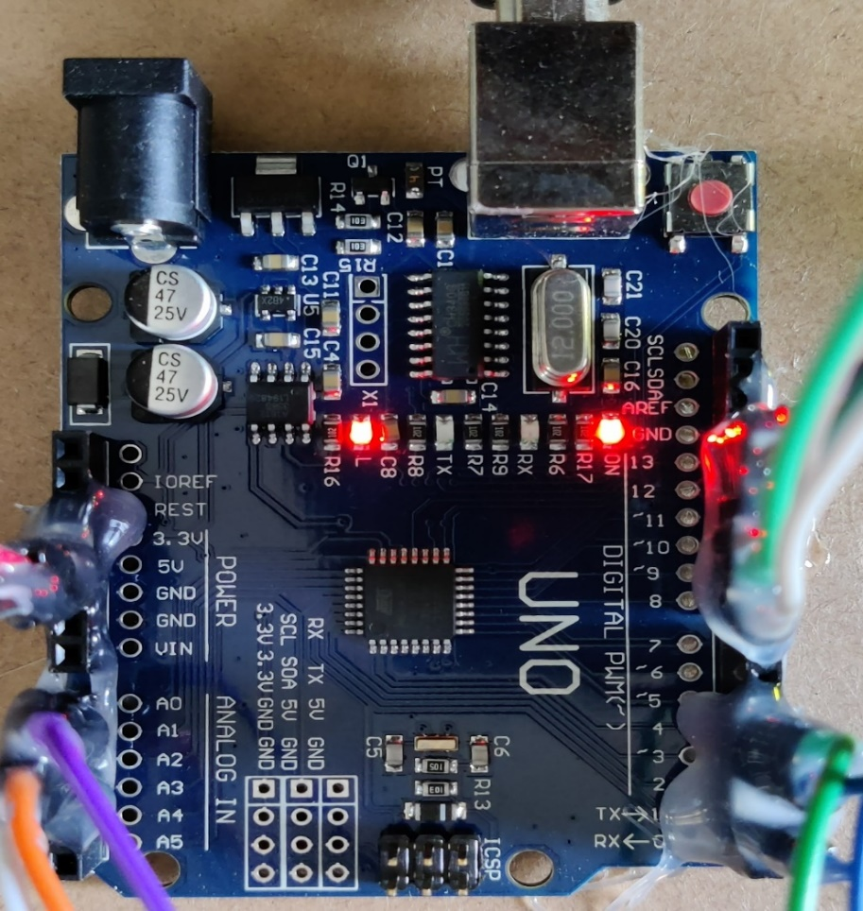

Fig 1: Arduino UNO

**2. GSM MODULE**

GSM module is used to establish communication between a computer and a GSM system. Global Systemfor Mobile communication (GSM) is an architecture used for mobile communication in most of the countries. Global Packet Radio Service (GPRS) is an extension of GSM that enables higher data transmission rate. GSM/GPRS module consists of a GSM/GPRS modem assembled together with power supplycircuit and communication interfaces (like RS-232, USB, etc) for computer. GSM/GPRS MODEM is a class of wireless MODEM devices that are designed for communication of a computer with the GSM and GPRS network. It requires aSIM (Subscriber Identity Module) card just like mobile phones to activate communication with the network. Also they have IMEI (International Mobile Equipment Identity) number similar to mobile phones for their identification. A GSM/GPRS MODEM can perform the following operations:

1.      Receive, send or delete SMS messages in a SIM.

2.      Read, add, search phonebook entries of the SIM.

3.      Make, Receive, or reject a voice call.

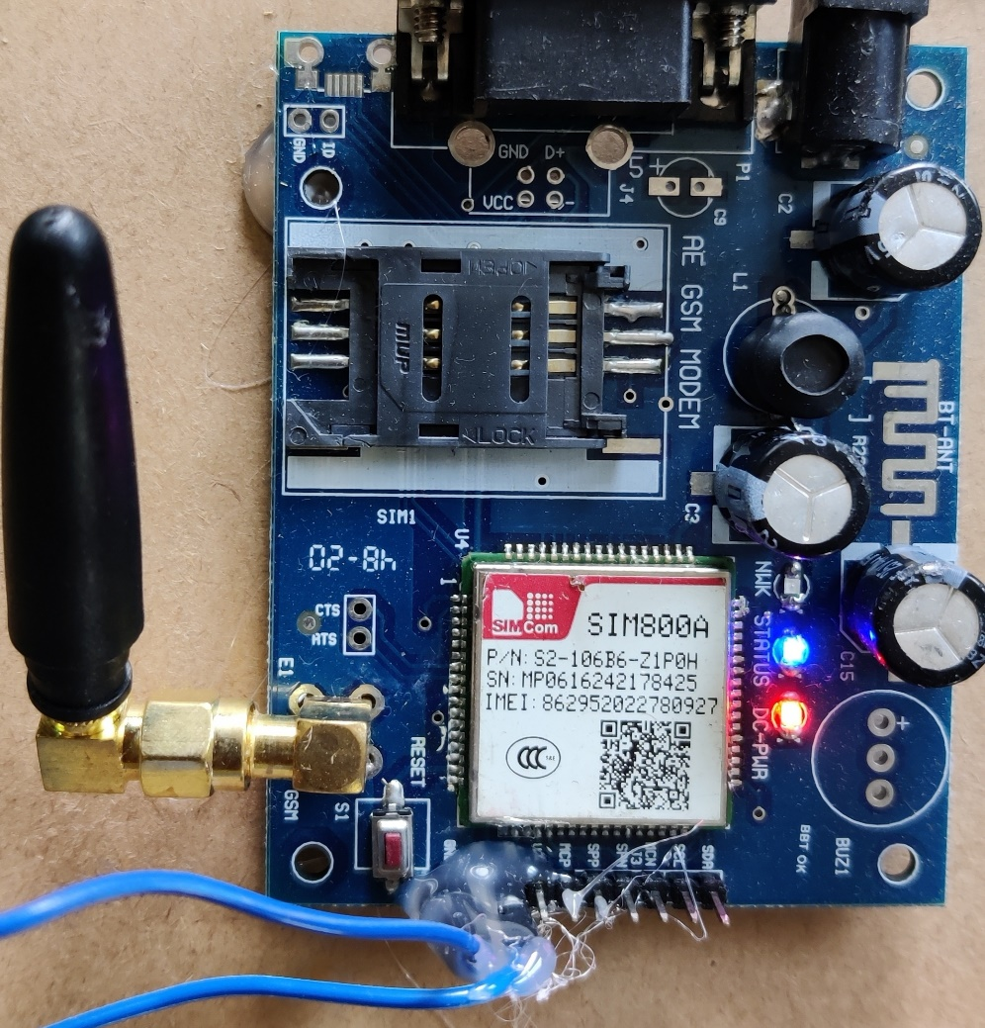

Fig 2: GSM Module

**3. FLAME SENSOR**

A flame-sensor is one kind of detector which is mainly designed for detecting as well as responding to the occurrence of a fire or flame. The flame detection response can depend on its fitting. It includes an alarm system, a natural gas line, propane & a fire suppression system. This sensor is used in industrial boilers. The main function of this is to give authentication whether the boiler is properly working or not. The response of these sensors is faster as well as more accurate compare with a heat/smoke detector because of its mechanism while detecting the flame.

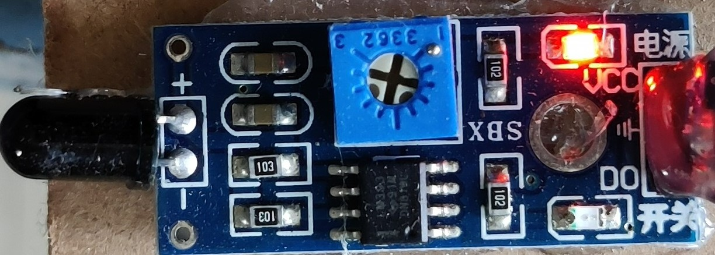

Fig 3: Flame Sensor

**4. SMOKE DETECTOR**

A Smoke Detector device is a smoke sensing device that indicates a fire. Smoke Detectors are very useful in homes, offices, schools, and industries. Smoke Detectors are extraordinarily useful devices because the damage caused by fire accidents is catastrophic. Nowadays, smoke detectors and smoke alarms are very low-priced as their usage is increasing and the cost of manufacturing is decreasing.

There are two main types of smoke detectors: photoelectric and ionization. When smoke enters the detector chamber, a photoelectric type detects sudden scattering of light, whereas an ionization type detects the change of electrical current flow that triggers the signal - indicating the presence of smoke. Smoke detectors have an average life of about 10 years. Detectors need to be tested periodically and the batteries changed when required. Ionization types contain radioactive material called Americium. The amount of radiation from Americium, generally, is not harmful, but intake through the mouth or inhalation by children may cause health issues. When used at home, some detectors use both technologies in combination with heat detectors to be more accurate.

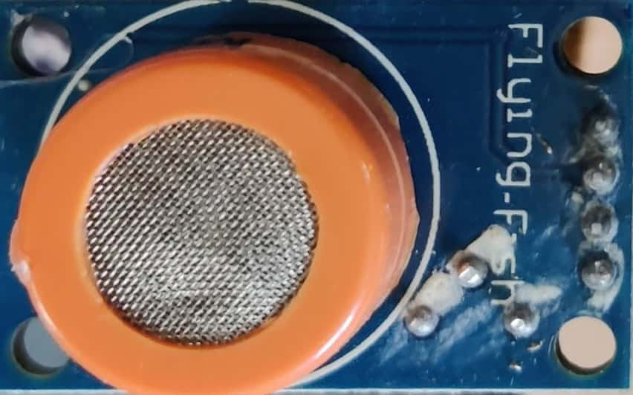

Fig 4: Smoke Detector

**5. BUZZER**

The buzzer is a sounding device that can convert audio signals into sound signals. It is usually powered by DC voltage. It is widely used in alarms, computers, printers and other electronic products as sound devices. It is mainly divided into piezoelectric buzzer and electromagnetic buzzer, represented by the letter "H" or "HA" in the circuit. According to different designs and uses, the buzzer can emit various sounds such as music, siren, buzzer, alarm, and electric bell.

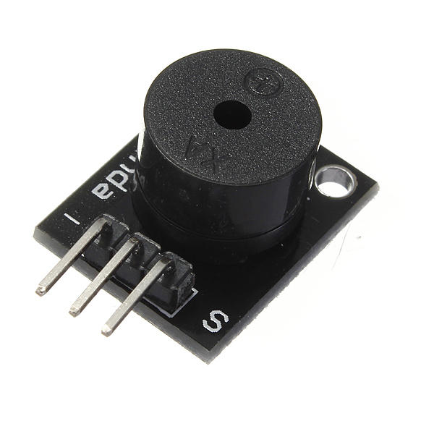

Fig 5: Buzzer

**6. BREADBOARD**

A Breadboard is simply a board for prototyping or building circuits on. It allows you to place components and connections on the board to make circuits without soldering. The holes in the breadboard take care of your connections by physically holding onto parts or wires where you put them and electrically connecting them inside the board. The ease of use and speed are great for learning and quick prototyping of simple circuits. More complex circuits and high frequency circuits are less suited to breadboarding. Breadboard circuits are also not ideal for long term use like circuits built on perfboard (protoboard) or PCB (printed circuit board), but they also don’t have the soldering (protoboard), or design and manufacturing costs (PCBs).

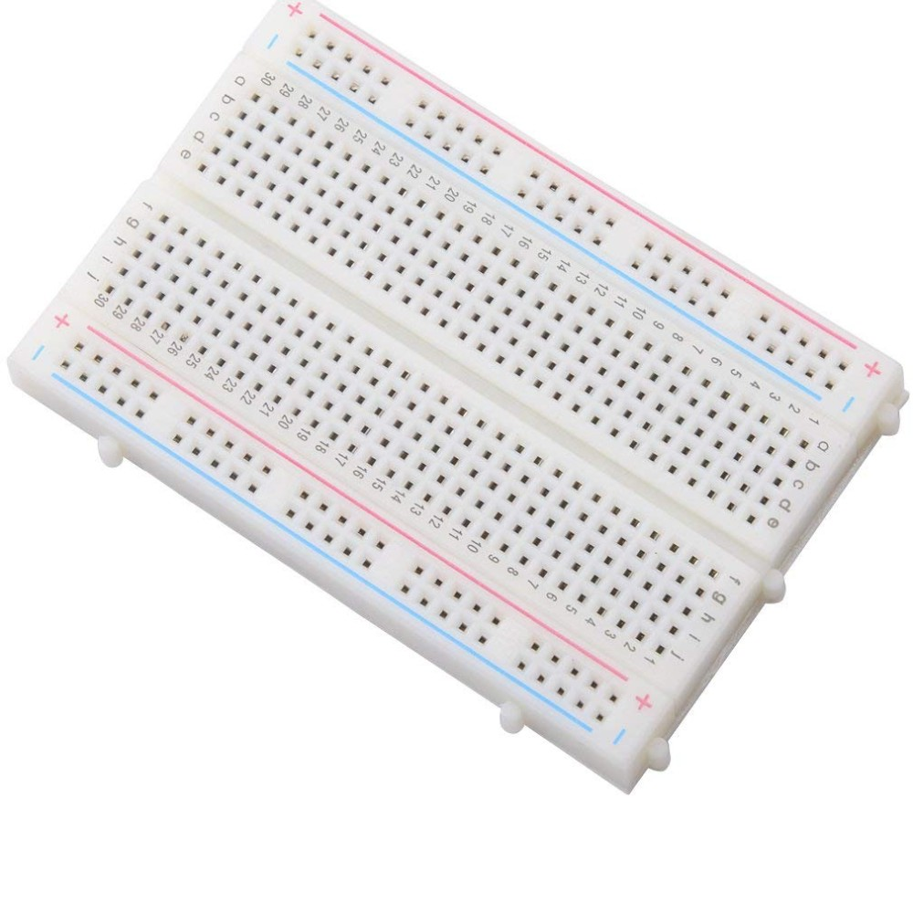

Fig 6: Breadboard

**7. LCD DISPLAY**

A**liquid-crystal display** ( LCD) is a flat-panel display or other electronically modulated optical device that uses the light-modulating properties of liquid crystals combined with polarizers. Liquid crystals do not emit light directly, instead using a backlight or reflector to produce images in colour or monochrome.

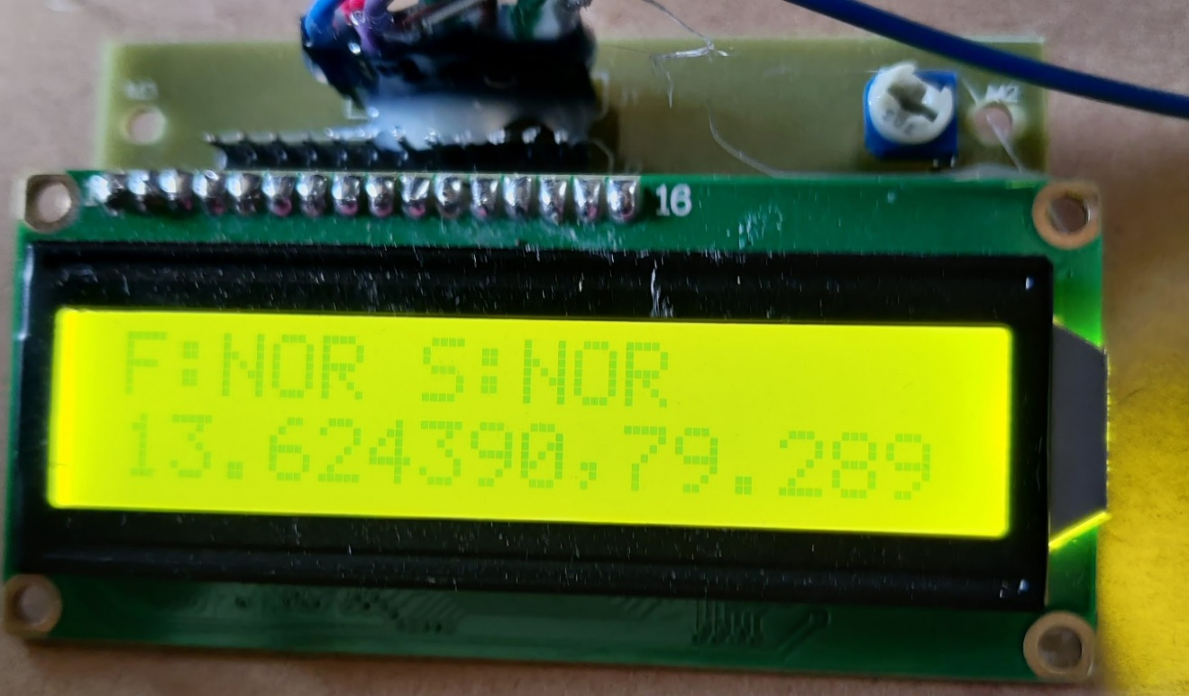

Fig 7: LCD Display

**8. GPS SENSOR**

As we know GPS stands for Global Positioning System. The system contains satellites and ground based control installations. GPS sensor consists of surface mount chip which processes signals from GPS satellites using a small rectangular antenna, often mounted on the top of the GPS chip.

• GPS module is usually small board on which GPS sensor is mounted with additional components.  
• GPS receiver is a device which includes data display and other components such as memory for data storage in addition to GPS module.

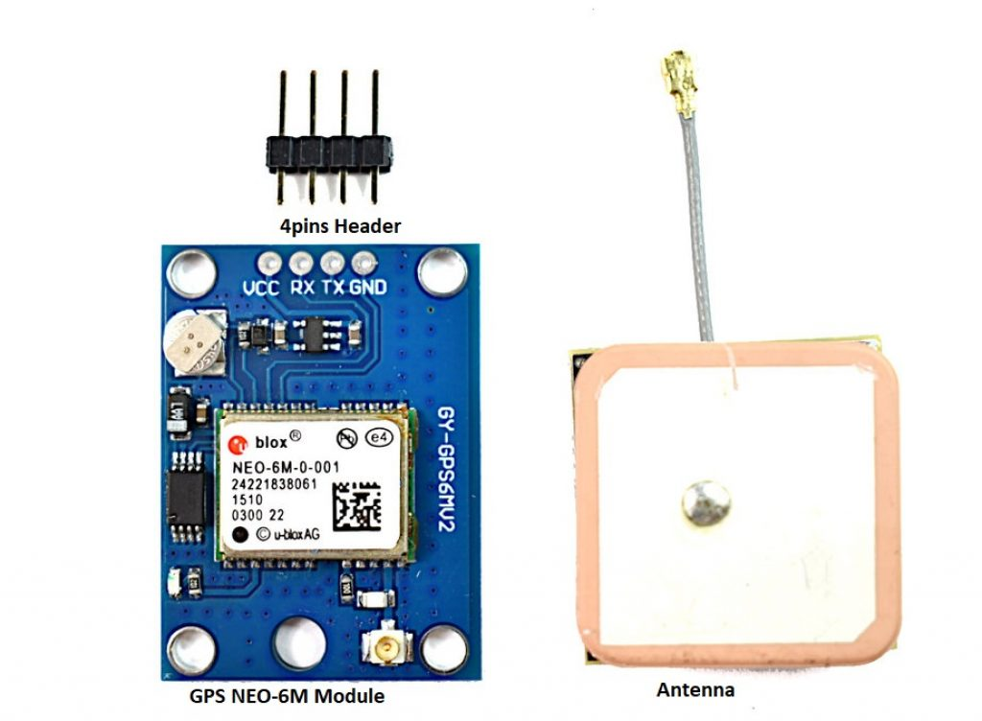

Fig 8: GPS Sensor

**3.2 WORKING PRINCIPLE OF FIRE AND SMOKE DETECTION SYSTEM**

An addressable fire alarm system works by having every detection and notification device connected to each other and to the addressable fire alarm control panel. An addressable system sends digital signals in binary code, as opposed to a conventional fire alarm system which operates through electrical currents. Addressable systems operate like a computer and convert variations in voltage to binary code, various combinations of zeros and ones.

This allows for an addressable fire alarm system to transfer critical information to the control panel with a broader range of information. An addressable system can pinpoint the exact location of smoke or fire, providing an increased level of safety and reliability.

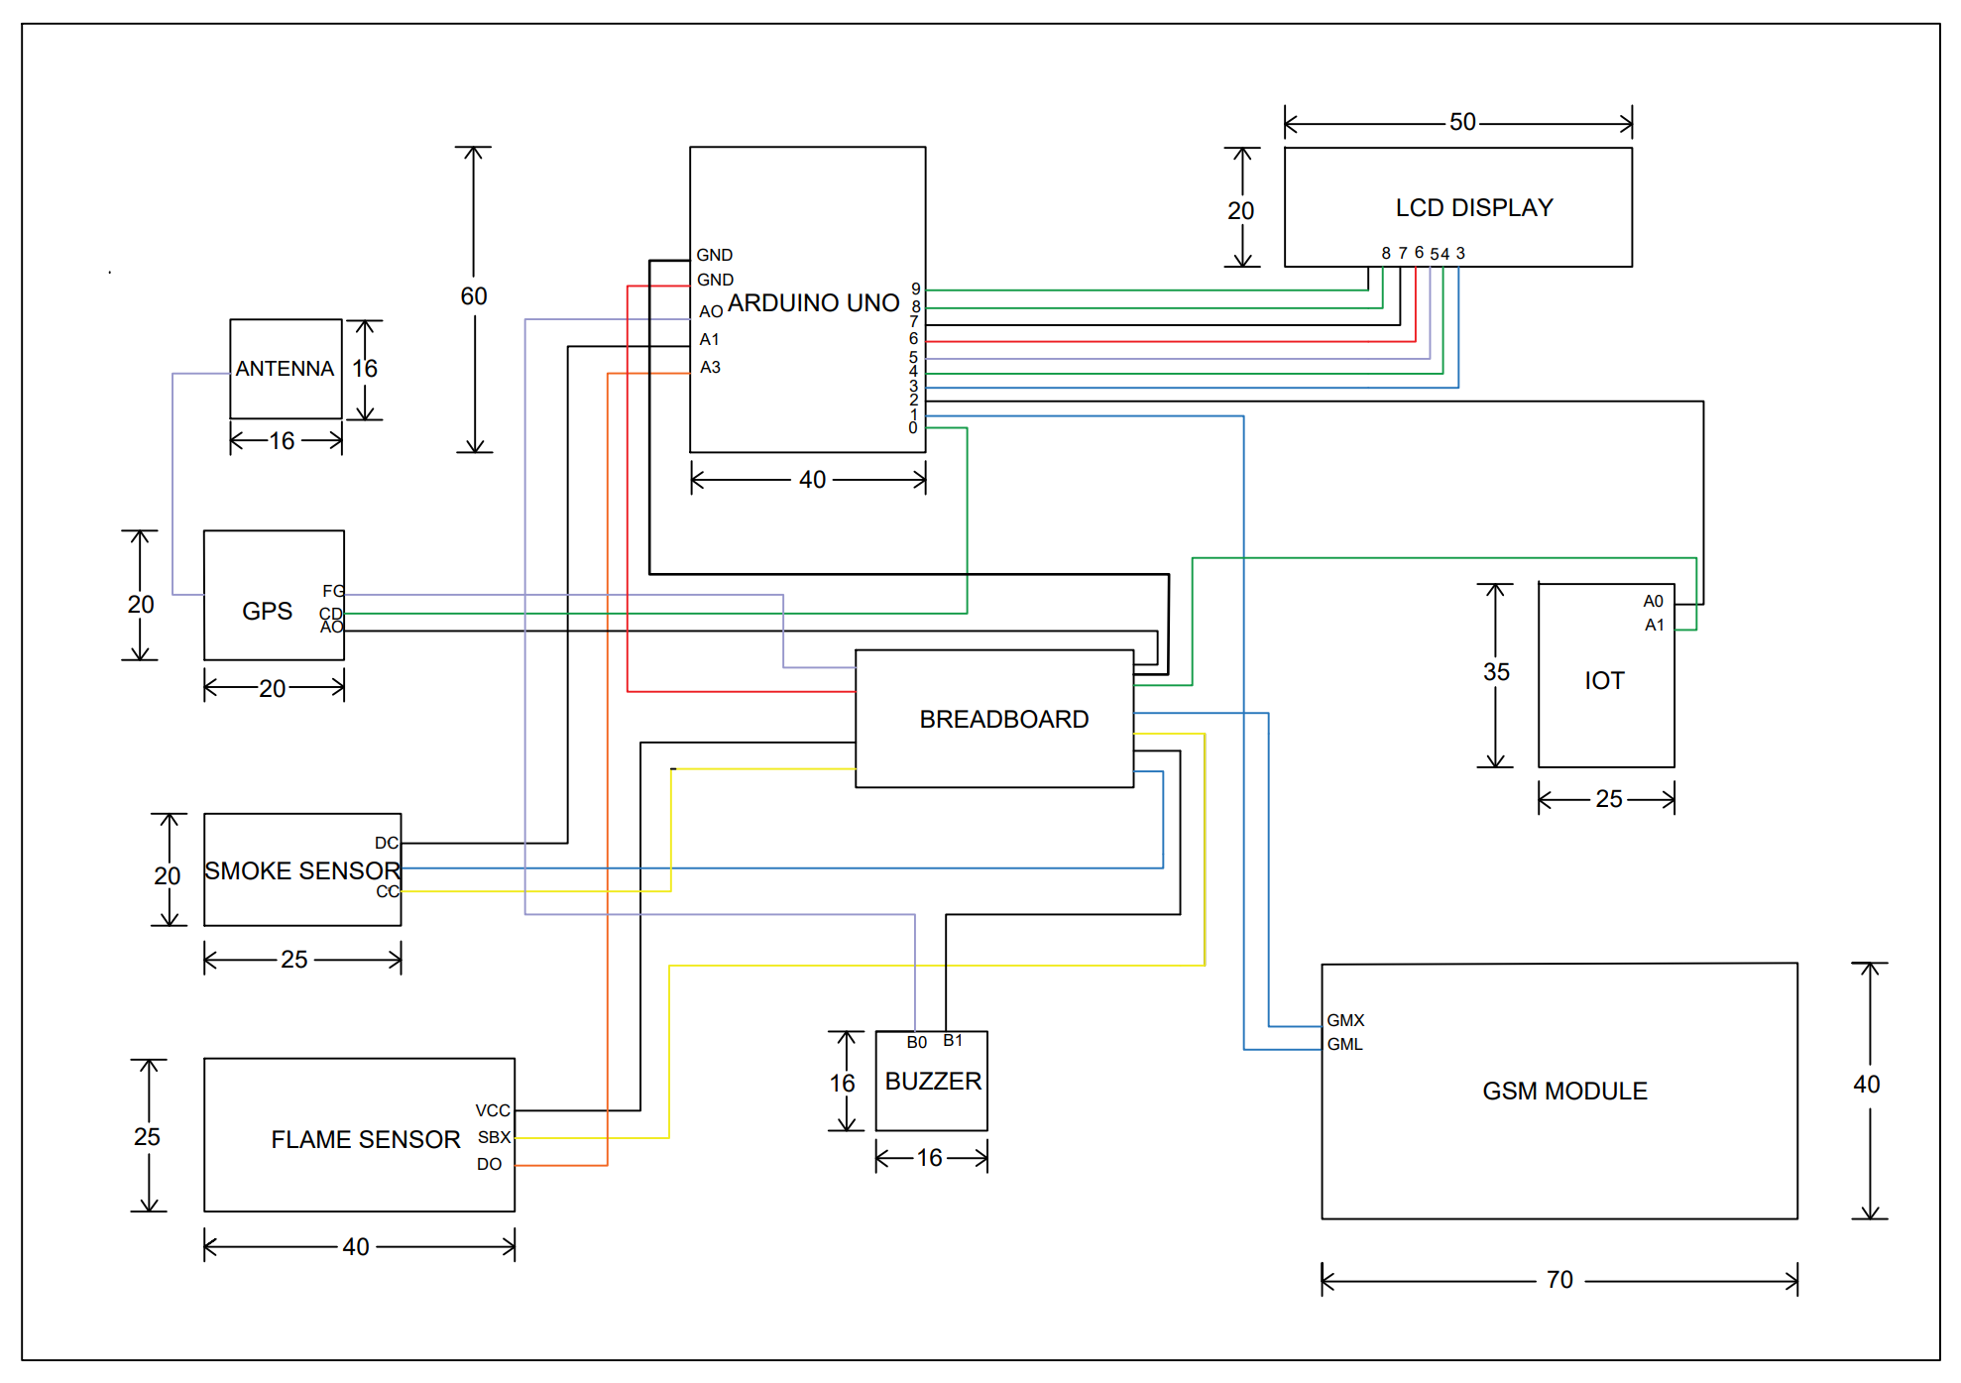

Fig 9: Plan for fire and smoke detection system

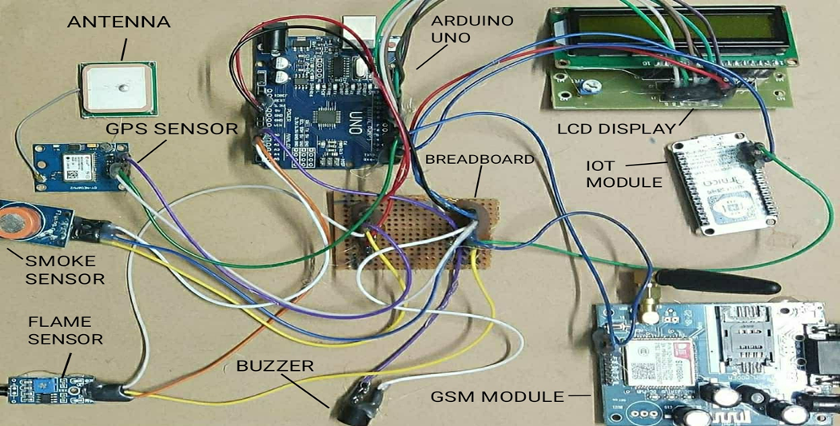

Fig 10: Fire and smoke detection system model

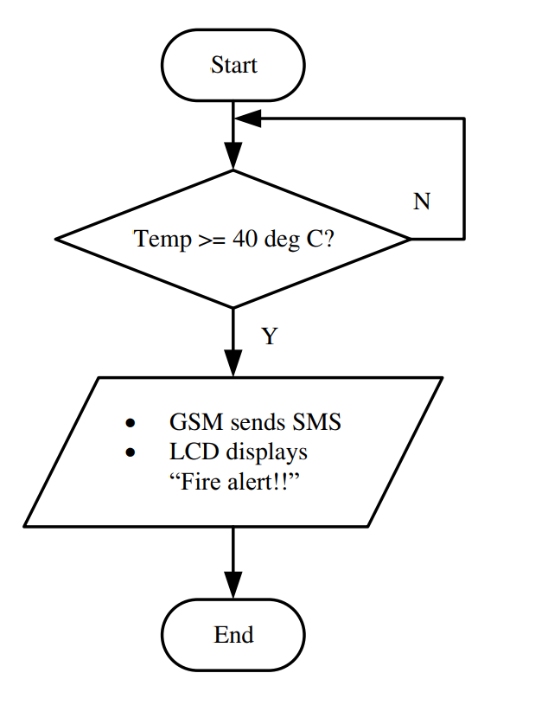

Fig 11: Flow chart for fire and smoke detection system.

**3.3 C PROGRAMMING CODE FOR FIRE AND SMOKE DETECTION SYSTEM**

#include <SoftwareSerial.h>

#include <stdlib.h>

#include <stdio.h>

#include "TinyGPS++.h"

TinyGPSPlus gps;

static const uint32_t GPSBaud = 9600;

double latitude;

double longitude;

String gpslocation;

String latistring="0";

String longistring="0";

SoftwareSerial ss(4, 3); // create gps sensor connection 4- RX- GPS 3-TX-GSM

#include <LiquidCrystal.h>

LiquidCrystal lcd(13, 12, 11, 10, 9, 8);

#include <SimpleTimer.h>

SimpleTimer fstimer;

SimpleTimer alertsendtimer;

SimpleTimer gpstimer;

SimpleTimer nodesendtimer;

char num[20] = "8978063128";

char num2[20] = "9640739947";

// defines pins numbers

const int buzzerPin = A0;

const int firePin = A1;

const int smokePin = A2;

// defines variablesx

int smokedata;

int firedata;

int alerttimerId;

int alerttimerstart = 0;

int smssent = 0;

int switchpressed = 0;

String firestatus="NORM";

String smokestatus="NORM";

String nodefire="NORMAL";

String nodesmoke="NORMAL";

void setup() {

Serial.begin(9600); // Starts the serial communication

// set the data rate for the SoftwareSerial port

ss.begin(9600); // connect gps sensor

// pinMode(smokePin, INPUT);

pinMode(firePin, INPUT);

pinMode(buzzerPin, OUTPUT);

nodesendtimer.setInterval(10000, sendingnodedata);

digitalWrite(buzzerPin, 0);

lcd.begin(16, 2);

lcd.clear();

lcd.setCursor(0, 0);

lcd.print(" FIRE AND SMOKE");

lcd.setCursor(0, 1);

lcd.print(" ALERT SYSTEM ");

delay(2000);

}

void loop() {

firesmokescan();

nodesendtimer.run();

while (ss.available() > 0)

if (gps.encode(ss.read()))

displayInfo();

if (millis() > 5000 && gps.charsProcessed() < 10)

{

// Serial.println(F("No GPS detected: check wiring."));

while (true);

}

lcd.clear();

lcd.setCursor(0, 0);

lcd.print("F:");

lcd.print(firestatus);

lcd.print(" ");

lcd.print("S:");

lcd.print(smokestatus);

lcd.setCursor(0, 1);

lcd.print(latistring);

lcd.print(",");

lcd.print(longistring);

delay(1000);

}

void displayInfo()

{

if (gps.location.isValid())

{

// Serial.print(gps.location.lat(), 6);

latitude = gps.location.lat(), 6;

// Serial.print(latitude ); Serial.print(F(","));

// Serial.print(gps.location.lng(), 6);

longitude = gps.location.lng(), 6;

//Serial.print(longitude);

latistring = String(latitude, 6);

longistring = String(longitude, 6);

}

else

{

// Serial.print(F("INVALID"));

}

latistring = String(latitude, 6);

longistring = String(longitude, 6);

//Serial.println();

}

void firesms() {

//Serial.println(F(" *********** FIRE SMS FUNCTION ********************"));

ss.print("AT+CMGF=1");

ss.print("\r\n");

delay(2000);

ss.print("AT+CMGS=\"");

ss.print(num);

ss.println("\"");

delay(2000);

ss.print("\r\n");

ss.print("ALERT: FIRE DETECTED");

ss.print("\n");

ss.print("http://maps.google.com/?q=");

ss.print(latistring);

ss.print(",");

ss.print(longistring);

delay(1000);

ss.println("\x1a");

delay(10000);

ss.print("AT+CMGF=1");

ss.print("\r\n");

delay(2000);

ss.print("AT+CMGS=\"");

ss.print(num2);

ss.println("\"");

delay(2000);

ss.print("\r\n");

ss.print("ALERT: FIRE DETECTED");

ss.print("\n");

ss.print("http://maps.google.com/?q=");

ss.print(latistring);

ss.print(",");

ss.print(longistring);

delay(2000);

ss.println("\x1a");

delay(10000);

alldefault();

}

void smokesms() {

// Serial.println(F(" *********** SMOKE SMS FUNCTION ********************"));

ss.print("AT+CMGF=1");

ss.print("\r\n");

delay(2000);

ss.print("AT+CMGS=\"");

ss.print(num);

ss.println("\"");

delay(2000);

ss.print("\r\n");

ss.print("ALERT:SMOKE DETECTED");

ss.print("\n");

ss.print("http://maps.google.com/?q=");

ss.print(latistring);

ss.print(",");

ss.print(longistring);

delay(1000);

ss.println("\x1a");

delay(10000);

ss.print("AT+CMGF=1");

ss.print("\r\n");

delay(2000);

ss.print("AT+CMGS=\"");

ss.print(num2);

ss.println("\"");

delay(2000);

ss.print("\r\n");

ss.print("ALERT:SMOKE DETECTED");

ss.print("\n");

ss.print("http://maps.google.com/?q=");

ss.print(latistring);

ss.print(",");

ss.print(longistring);

delay(2000);

ss.println("\x1a");

delay(10000);

alldefault();

}

void firesmokescan() {

smokedata = analogRead(smokePin);

firedata = digitalRead(firePin);

// Serial.println();

// Serial.println(F("============================"));

// Serial.print(F("SMOKE PIN DATA : ")); Serial.println(smokedata);

// Serial.print(F("FIRE : ")); Serial.println(firedata);

// Serial.println(F("============================"));

if (firedata == 0) {

// Serial.println(F("=========== FIRE DETECTED ========================="));

firestatus="DETE";

nodefire="DETECTED";

if (smssent == 0) {

lcd.clear();

lcd.setCursor(0, 0);

lcd.print("FIRE DETECTED");

lcd.setCursor(0, 1);

lcd.print("SENDING SMS...");

smssent = 1;

digitalWrite(buzzerPin, 1);

sendingnodedata();

firesms();

digitalWrite(buzzerPin, 0);

smssent = 0;

}

}

else {

firestatus="NOR";

nodefire="NORMAL";

}

if (smokedata > 900) {

//Serial.println(F("=========== SMOKE DETECTED ========================="));

smokestatus="DETE";

nodesmoke="DETECTED";

if (smssent == 0) {

smssent = 1;

lcd.clear();

lcd.setCursor(0, 0);

lcd.print("SMOKE DETECTED");

lcd.setCursor(0,1 );

lcd.print("SENDING SMS...");

digitalWrite(buzzerPin, 1);

sendingnodedata();

smokesms();

digitalWrite(buzzerPin, 0);

smssent = 0;

}

}

else {

smokestatus="NOR";

nodesmoke="NORMAL";

}

}

void alldefault() {

smssent = 0;

}

void sendingnodedata(){

Serial.print("#");

Serial.print(nodefire);

Serial.print("/");

Serial.print(nodesmoke);

Serial.print("/");

Serial.print(latistring);

Serial.print("/");

Serial.print(longistring);

delay(500);

}

**3.4 ADVANTAGES OF FIRE AND SMOKE DETECTING SYSTEM**

**1. Avoid Smoke Inhalation**

The most important reason is perhaps the only one you really need. This can save the life of anyone in the house at the time. This is particularly crucial at night time. Anyone who is sleeping may not be awakened in time if a fire starts. Many times people die of smoke inhalation while trying to escape. Having a system in place can give you peace of mind and security.

**2. Early Detection**

The earlier a fire is detected, the faster it will be that firefighters will respond. This can mean you may avoid major damage or even worse, the complete destruction of the home**.**

**3. 24/7 Monitoring**

A home fire alarm system gives the homeowner protection 24 hours a day, every day of the week. You home will be monitored when you are away, and at night when you are sleeping. You and your family can feel secure knowing this monitoring never stops.

**4. Easy & Affordable**

Having a system is very reasonably priced. Even if you have insurance that can replace any lost items, many of them are irreplaceable. This would include photo albums, gifts from family members or items passed down from one generation to the next. You also would be severely inconvenienced by having to live elsewhere for at least some time. Finally, there is the emotional trauma of losing your home and possessions.

**3.5 LIMITATION OF FIRE AND SMOKE DETECTING SYSTEM**

The amount of “smoke” present may be insufficient to alarm smoke detectors. Smoke detectors are designed to alarm at various levels of smoke density. If such density levels are not created by a developing fire at the location of detectors, the detectors will not go into alarm.

• Smoke detectors, even when working properly, have sensing limitations. Detectors that have photo-electronic sensing chambers tend to detect smoldering fires better than flaming fires, which have little visible smoke. Detectors that have ionizing-type sensing chambers tend to detect fast flaming fires better than smoldering fires. Because fires develop in different ways and are often unpredictable in their growth, neither type of detector is necessarily best and a given type of detector may not provide adequate warning of a fire.

• Smoke detectors are subject to false alarms and nuisance alarms. For example, a smoke detector located in or near a kitchen may go into nuisance alarm during normal operation of kitchen appliances.

In addition, dusty or steamy environments may cause a smoke detector to falsely alarm. If the location of a smoke detector causes an abundance of false alarms or nuisance alarms, do n disconnect the smoke detector; call a professional to analyze the situation and recommend a solution.

• Smoke detectors cannot be expected to provide adequate warning of fires caused by arson, children playing with matches (especially within bedrooms), smoking in bed, violent explosions (caused by escaping gas, improper storage of flammable materials, etc.

• System components will not work without electrical power. If system batteries are not serviced or Replaced regularly, they may not provide battery backup when AC power fails.

• Environments with high air velocity or that are dusty or dirty require more frequent maintenance and disconnect the smoke detector; call a professional to analyze the situation and recommend a solution.

**3.6 CONCLUSION**

Smoke detectors are great because they save lives. You should place a smoke detector a certain inches far from a wall. Smoke detectors must always be associate exceedingly house or an housing. There are totally different shapes of smoke detectors, however those that area unit a circle form are those who are in most homes. There also are smoke detectors formed as noses, to smell for smoke. There should be a minimum of two or three smoke detectors in your home. You should install a smoke detector on each floor of a house. Always have a smoke detector and fire alarm system in your home for your own Safety**.**

**REFERENCES**

1. Rasika. S., Manita Rajput (2015) "Smart home for elderly care, based on Wireless Sensor Network." 2015 International Conference on Nascent Technologies in the Engineering Field (ICNTE). IEEE, 2015.

2. Rakesh. V., Sreesh. P., George. S.N., (2012) "Improved real-time surveillance system for home security system using Beagleboard SBC, Zigbee and FTP Webserver," 2012 Annual IEEE India Conference (INDICON), pp. 1240 - 1244,2012.

3.Krishna. A.R., Bala. G.S., Sastry. A., Sarma. B.B., Alia. G.S., (2012) "Design And Implementation Of A Robotic Arm Based On Haptic Technology," International Journal of Engineering Research and Applications (IJERA), vol. 2, no. 3, pp. 3098- 3103,2012.

4. Suresh. S., (2016) “Home Based Fire Monitoring And Warning System,” 2016.

5. Chun-yuan. L., (2011) “Design of Intelligent Fire Alarm System Based on GSM Network,” no. Iceoe, pp. 393–396, 2011

6. Faris. M., Fuzi. M., Ibrahim. A., Ismail. M.H., Syakira. N., and Halim. A., (2014) “HOME FADS : A Dedicated Fire Alert Detection System Using ZigBee Wireless Network,” pp. 53–58, 2014.

7. Sen. K., Sarkar. J., Saha. S., Roy. A., Dey. D., Baitalik. S., (2015) “Automated Fire Detection and Controlling System,” Int. Adv. Res. J. Sci. Eng. Technol., vol. 2, no. 5, pp. 34–37, 2015.

8. Shufian. A., Rahman. M.M., Ahmed. K., Islam. R., Hasan. M., and Islam. T., (2019)“Design and implementation of solar power wireless battery charger,” IEEE Int. Conf. Adv. Sci., Eng. Robot. Technol., Dhaka, Bangladesh, May 3–5, 2019, in press.

9. Habib. M.R., Ahmed. K., Khan. N., Kiran. M.R., Habib. M.A., Hasan. M.T., Farrok. K., (2019)“PID controller based automatic solar power driven grass cutting machine,” IEEE Int. Conf. Comput., Commun., Chemical, Mater. Electron. Eng., Rajshahi, Bangladesh, Jul. 11–12, 2019, in press.

10. Sowah. R., Ofoli. A.R., Krakani. S., and Fiawoo. S., (2014) “A web-based communication module design of a real time multi-sensor fire detection and notification system,” IEEE Ind. Apl. Soci. Ann. Meeting, Vancouver, BC, Canada, Oct. 5–9, 2014.